**BigQuery Health Check Metadata Download Guide**



| Product Version | 4.8.1 |
| --- | --- |
| Document Type | Health Check Preparation Guide |
| Authors | BigQuery Data source Team |
| Reviewer | Red Team & Architects |
| Approver | CTO |
| Total Pages | 6 |
| Document Status | Draft |

Table Of Contents

**1.1** **Objectives 2**

**1.2** **Architecture 2**

**1.3** **Pre-requisite 2**

**1.4** **Download BigQuery Metadata for health check. 3**

**1.5** **Output Files 5**

Document Version Record

| Date | Version # | Author | Remarks / Reason |
| --- | --- | --- | --- |
| 08-Sep-23 | 1.0 | Dev Team | New Document |

## Objectives

Health check download for bigquery unravel product.

## Architecture

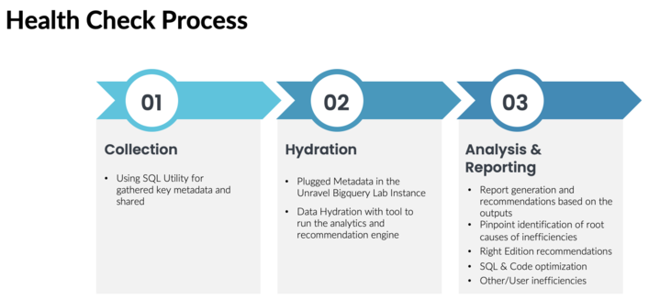

## Pre-requisite

1. **BigQuery Permissions/roles required :** 
   1. Health check data download from bigquery
      1. For querying INFORMATION_SCHEMA.JOBS & INFORMATION_SCHEMA.JOBS_TIMELINE view data ask your administrator to grant you the [BigQuery Resource Viewer](https://cloud.google.com/iam/docs/understanding-roles#bigquery.resourceViewer) (roles/bigquery.resourceViewer) IAM role on your project. This predefined role contains the **bigquery.jobs.listAll** permission, which is required to query the INFORMATION_SCHEMA.JOBS & INFORMATION_SCHEMA.JOBS_TIMELINE view.
      2. For querying INFORMATION_SCHEMA.RESERVATIONS view and INFORMATION_SCHEMA.ASSIGNMENTS view, you need the **bigquery.reservations.list** and **bigquery.reservationAssignments.list** Identity and Access Management (IAM) permission for the project. Each of the following predefined IAM roles includes the required permission:
         1. roles/bigquery.resourceAdmin
         2. roles/bigquery.resourceEditor
         3. roles/bigquery.resourceViewer
         4. roles/bigquery.user
         5. roles/bigquery.admin

## Download BigQuery Metadata for health check.

Do the following to download BigQuery metadata:

1. Download the following files from this location :   
   <https://github.com/unraveldata-org/BigQuery-data-loader/tree/main/BigQuery%20Queries>

* download_bigquery_jobs_data.txt
* download_bigquery_jobs_timeline_data.txt
* download_bigquery_assignment_data.txt
* download_bigquery_reservation_data.txt
* download_billing_data.txt

1. Create a gcs bucket and replace unravel-bucket/folder_name/ in above txt files with your valid gcs URI (Please find the steps below on How to create a gcs bucket).
2. For each region, replace the $region with your region and $my-project_id with your project id and execute the download_bigquery_jobs_data.txt and download_bigquery_jobs_timeline_data.txt for each project and for each region where the queries in that project are ran or the dataset in that project belongs to.
3. Replace $admin_project_id with your admin project id and $region with your region in download_bigquery_assignment_data.txt and ownload_bigquery_reservation_data.txt
4. In download_billing_data.txt replace, $project , $dataset, and $table_name with the project, dataset and table_name where you have exported the billing data.

For Example :   
$project = **unravel-flat-rate-test**

$dataset = **all_billing_data**

$table_name = **gcp_billing_export_resource_v1_016A85_2365E3_979331**

1. Execute each of the above BigQuery for each region(s) on the BigQuery console on your project.
2. Check in the gcs bucket, there must be some csv files created with prefix YOUR_REGION_JOBS_* , YOUR_REGION_JOBS_TIMELINE_* , YOUR_REGION_RESERVATIONS_* , YOUR_REGION_ASSIGNMENTS_* in the gcs bucket folder that you have defined in the export bigquery options.
3. Select each of these files and click on Download.

Steps for creating a gcs bucket :

1. Go to the Cloud Storage Buckets page: <https://console.cloud.google.com/storage/browser> in the Google Cloud console.
2. Click + Create.
3. On the Create a bucket page, enter the following information:
   1. Name your bucket: Enter a unique name for your bucket. The name must start with a lowercase letter or number, and it can contain up to 63 characters. It can also contain dashes and periods.
   2. Choose where to store your data: Select a location for your bucket. You can choose a location in the same region as your project, or you can choose a different region.
   3. Choose a storage class for your data: Select a storage class for your bucket. The storage class determines how long your data is kept and how much it costs to store.
4. Click Create.
5. Create new folder in bucket [OPTIONAL]

## Output Files (Sample)

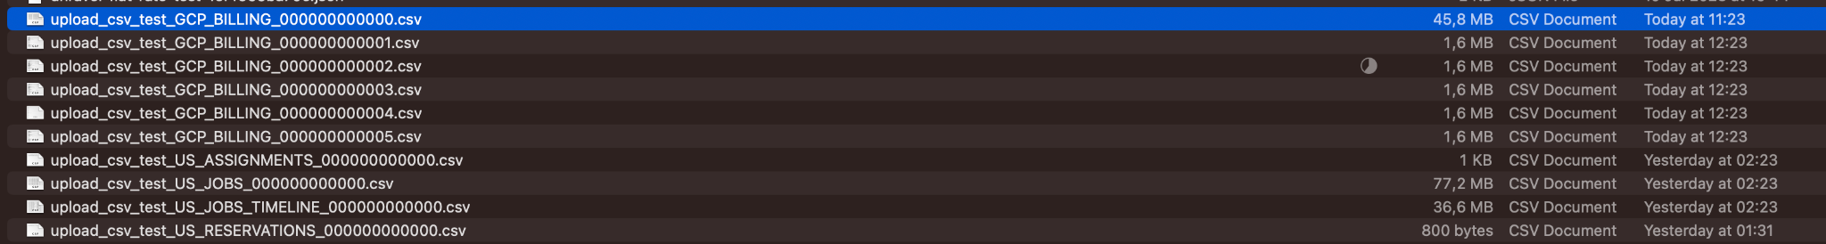

## Video Guide

Part 1 (for downloading JOBS & JOBS_TIMELINE Data): <https://drive.google.com/file/d/1KNPY6LctE4ys9uv_SHdkGLrXeJWYnv5q/view?usp=drive_link>

Part 2 (for downloading ASSIGNMENTS & RESERVATION Data):

<https://drive.google.com/file/d/1YoWsnvzT2bPYAkwUnKLK1EcDJcS-gtuf/view?usp=drive_link>

Part 3 (for downloading BILLING Data):

<https://drive.google.com/file/d/13nSEWrUMV7oLHukemh3tod58ySfYGNiu/view?usp=drive_link>